

Lab Journal: 03
Date: 02/20/2026

Student : Lotfullah Muslimwal
Enrollment : 01-131232-039

Department of Software Engineering

Bahria University, Islamabad

Artificial Intelligence - Lab (Spring-2026)
Teacher: ENGR. SAAD MAZHAR Khan

Task No: | Task Wise Marks |  | Documentation Marks |  | Total Marks  (20)
 | Assigned | Obtained | Assigned | Obtained
1 | 3 |  | 5
2 | 3
3 | 3
4 | 3
5 | 3

Comments:

Signature

OOP in Python (Part-4) (Functions, Classes, Inheritance, Polymorphism)

Task1:
Create a base class Shape with an abstract method calculate_area(). Implement the calculate_area() method in the following subclasses:
- Rectangle (Length × Width)
- Square (Side²)
- Circle (π × Radius²)
- Cylinder (2πr(r + h))
Test your classes by creating objects for each shape and calculating their areas.

Code:
from abc import ABC, abstractmethod
import math

class Shape(ABC):

def __init__(self, name):
self.name = name

@abstractmethod
def calculate_area(self):
pass

def display_info(self):
print(f"{self.name} - Area: {self.calculate_area():.2f}")

class Rectangle(Shape):
def __init__(self, length, width):
super().__init__("Rectangle")
self.length = length
self.width = width

def calculate_area(self):
return self.length * self.width

class Square(Shape):
def __init__(self, side):
super().__init__("Square")
self.side = side

def calculate_area(self):
return self.side ** 2

class Circle(Shape):
def __init__(self, radius):
super().__init__("Circle")
self.radius = radius

def calculate_area(self):
return math.pi * self.radius ** 2

class Cylinder(Shape):
def __init__(self, radius, height):
super().__init__("Cylinder")
self.radius = radius
self.height = height

def calculate_area(self):
# Surface area: 2πr(r + h)
return 2 * math.pi * self.radius * (self.radius + self.height)

# Test the classes
if __name__ == "__main__":
rect = Rectangle(10, 5)
square = Square(4)
circle = Circle(3)
cylinder = Cylinder(3, 7)

rect.display_info()
square.display_info()
circle.display_info()
cylinder.display_info()
Screenshot
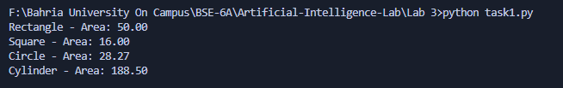

Tasks 2 :Implement a lambda expression to calculate square of given number.
Code:
square = lambda x: x ** 2

if __name__ == "__main__":
number = float(input("Enter a number: "))
result = square(number)
print(f"Square of {number}: {result}")
Screenshot

Task 3: Implement a lambda expression to calculate the length of passed string.
Code
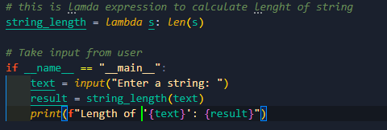
Screenshot
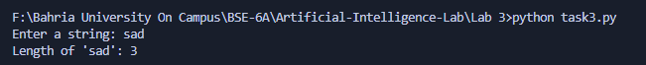
Task 4: Create a generator function that returns 5 random numbers between 1 and 100. Use a for loop to print the numbers
Code:
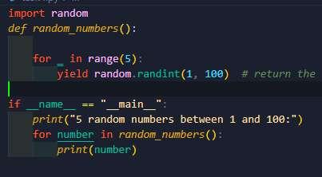
Screenshot
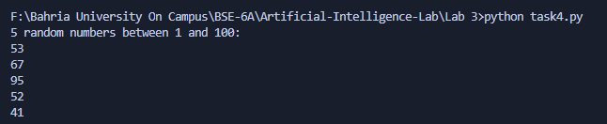
Task 5: Implement a generator function that returns the Fibonacci sequence up to a given limit n. Use a for loop to print the sequence.
Code
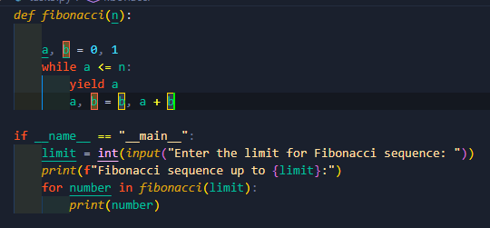
Screenshot
